Mesh Topology
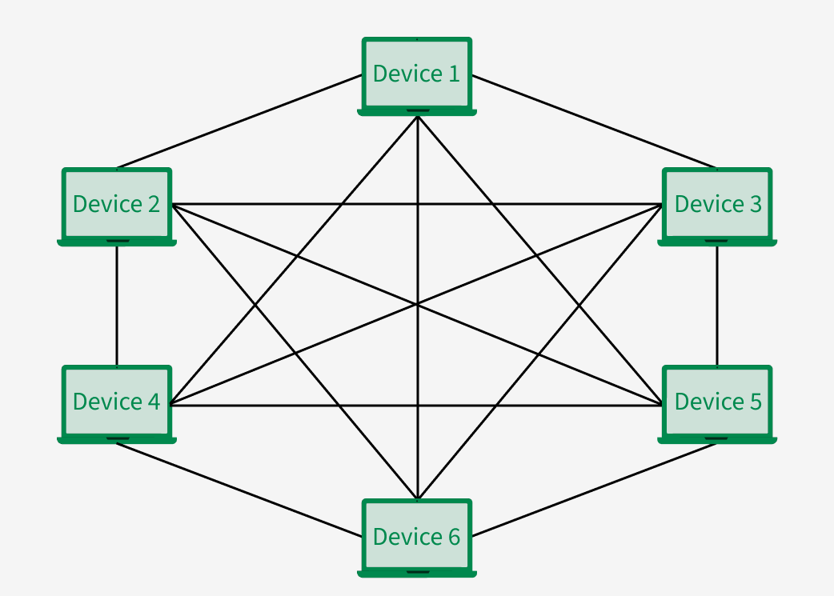
Mesh Topology is a network configuration where every device is interconnected with every other device, providing multiple route for data to travel. The nodes are connected to each other completely via a dedicated link during which information travels from nodes to nodes. If a mesh network has N nodes, then there are N(N-1)/2 links. Each computer not only sends its signals but also transfer data from other computers. The connections within the mesh are often wired or wireless. In this article, we will discuss the Mesh Topology in detail.
- Applications of Mesh Topology
- Wireless Networks
- Industrial and Manufacturing Networks
- Smart Homes
- Military Communication

Star Topology is a network setup in which each device is connected to a central node called a hub. The hub manages the data flow between the devices. If one device wants to send data to another device, it has to first send the information to the hub, and then the hub transmits that data to the required device.
Star Topology
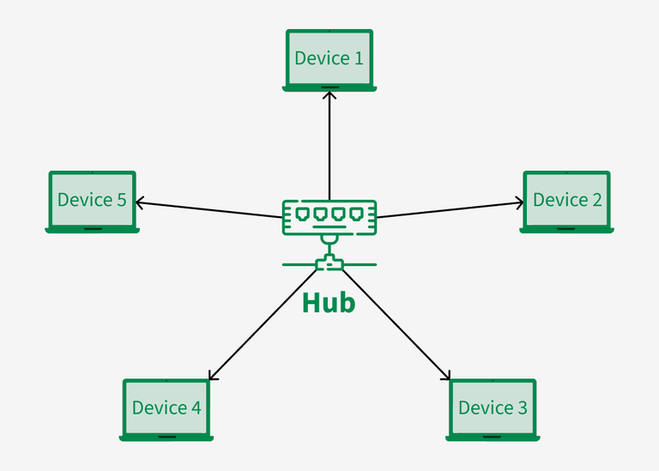
A star may be a Local Area Network (LAN) topology where all nodes are individually connected to a central connection point (hub). The number of links required to connect nodes in the star topology is N where N is the number of nodes. The hub or switch manages and controls all functions of the network.

As we know, all the nodes in a star topology are connected to the Hub, and the Hub is responsible for the transmission of the data in the network. Whenever any node wants to transmit data to another node, it first transmits data to the central node (hub), and then it transfers the data to all the nodes on the network. After receiving the data, the hub checks for the destination address, and if the address matches the data is accepted otherwise data is rejected.

- USES:
- Home Networks
- ATM Networks
- Hospital Networks
- CCTV Networks
Bus Topology
All of the devices in a bus topology network are linked together by a single cable, which is referred to as a "bus" and the cable is known as backbone cable. All of the network's devices can simultaneously receive the same signal due to the shared communication medium provided by this connection
Bus topology carries transmitted data through the cable because data reaches each node, the node checks the destination address (MAC/IP address) to determine if it matches their address. If the address does not match with the node, the node does nothing more. But if the addresses of nodes match to addresses contained within the data then they process knowledge. In the bus, communication between nodes is done through a foremost network cable.
Bus Topology is a network type in which every computer and network device is connected to a single cable. It is bi-directional. It is a multi-point connection and a non-robust topology because if the backbone fails the topology crashes. IBus-topology Ethernet uses only the CSMA/CD MAC protocol. TDMA, CDMA, Pure ALOHA, and Slotted ALOHA were never used in Ethernet.
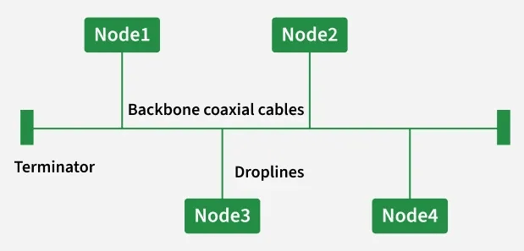
Key Features of Bus Topology
- An efficient bus architecture is established, and each station is connected by a single backbone cable.
- There are two requirements: Initially, the nodes are connected to the backbone cable directly, or they use a drop cable to help them connect.
- The well-known access method for bus topologies is called CSMA (Carrier Sense Multiple Access).
Ring Topology

A ring network topology consists of multiple computers or devices communicated in a closed-loop by a single communication medium. The information traverse around the ring to every station because it reaches the desired computer or device. It is so termed because of the circular method of the data flow. Generally, the data flow is unidirectional, but it must be bidirectional too. In a unidirectional ring, the data act in one direction only, while in bidirectional, it works in both directions.
It is another popular technique for network configuration. The ring network topology is displayed in the figure below
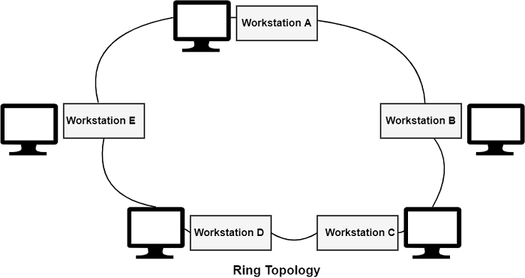
A ring network frequently uses a bit-serial transmission medium, including twisted pairs or coaxial cables. A master clock can be used to communicate to each station when to read and write bits, or the timing data can be encoded into the information as long as specific restrictions are met to keep up the ring from flooding.

